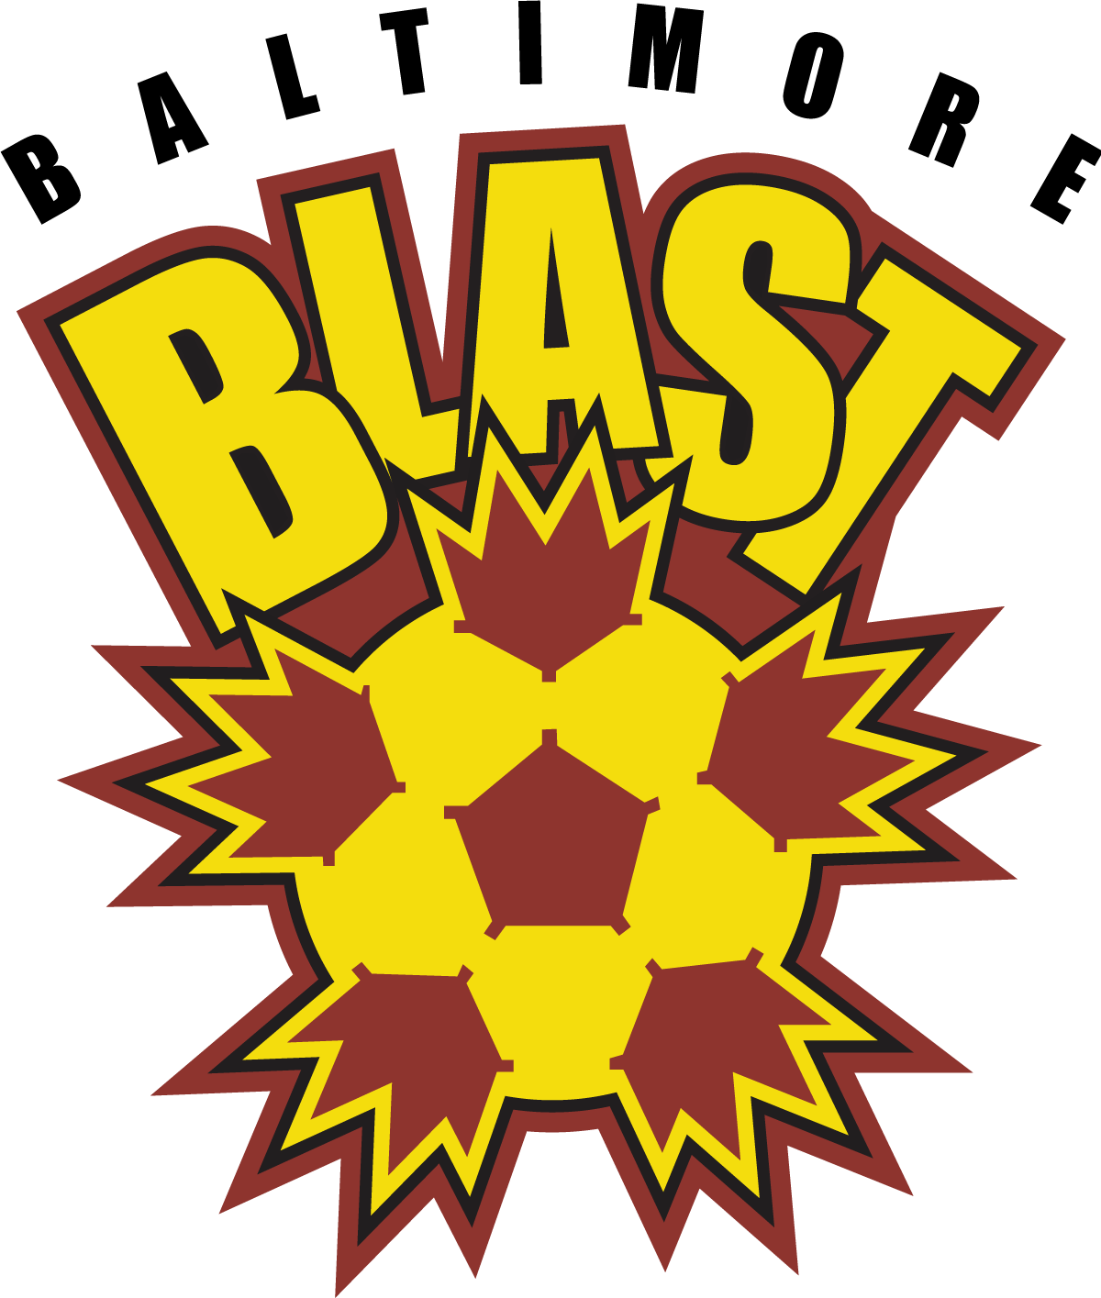
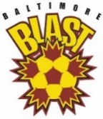
BALTIMORE BLAST 2024 SUMMER CAMP REGISTRATION

DATE | TIME | LOCATION | PRICE
June 17-21 | 9am-3pm | Northeast Regional Rec Center (Indoor) | $325
June 17-21 | 9am-12pm | Cedar Lane Park (Harford County) | $225
June 17-21 | 9am-12pm | Sparrows Point High School *** | -
June 24-28 | 9am-12pm | Southeast Regional rec Center | $225
June 24-28 | 9am-12pm | Meadowood Park (Girls only camp) | $225
July 8-12 | 9am-12pm | Latrobe Park | $225
July 8-12 | 9AM-12pm | Monsignor Slade School | $225
July 8-12 | 9aqm-12pm | Honeygo Park | $225
July 15-19 | 9am-12pm | Carroll Indoor Sports | $225
July 15-19 | 9am-12om | Cedar Lane Park (Harford County) | $225
July 15-19 | 9am-12pm | Churchville*** | -
July 15-19 | 9am-3pm | Northeast regional rec Center ( Indoor) | $325
July 24-28 | 9am-noon | Churchville **** | -
July 22-26 | 9am-12pm | Meadowood Park | $225
July 22-26 | 9am-12pm | Eastern Regional Park | $225
July 29-Aug 2 | 9am-12pm | Halethorpe Community Center | $225
July 29-Aug 2 | 9am-3pm | Southeast Regional Rec Center (indoor) | $325
Aug 5-9 | 9am-12pm | Cedar Lane Park (Bel Air) | $225
Aug 5-9 | 9am-12pm | Churchville*** | -
Aug 12-16 | 9am-3pm | Northeast Regional Rec Center (Indoor) | $325
Aug 12-16 | 9am-12pm | CCBC-Dundalk (Girls only camp) | $225
Aug 19-23 | 9am-12pm | Specialty Camp- TBD
All Baltimore County Camp locations are subject to county approval.
Camp attire: Each camper will need to wear a white t-shirt and Black shorts each day to camp.
Parent Name: Camper Name:
Address: City: State: Zip:
Phone #: Home: Work: Cell:
M/F: Age: Email Address:
Camp Location:

T-Shirt Size (Circle): Youth-S Youth-M Youth-L Adult-S Adult M Adult L Adult XL
Extra T-Shirt ($10) Size: Extra Soccer Ball ($20): Extended Care ($50___ (2hrs) Mask($5)__ Gaiter ($10)__
I do hereby for myself, my heirs, and assigns, waive and release any and all
(Parent Name)
claims to damage against the Baltimore Blast and any camp locations and its assigns or authorized representatives conducting camp as a result of any or all injuries incurred by traveling to or from, or while participating in the camp. (Camper Name)
Please send this form and nonrefundable full payment to: Baltimore Blast Summer Soccer Camps, 7006 Golden Ring Road, Baltimore, MD 21237 or fax the order form to 410-732-1737
Amount Paid: $ Credit Card (Circle): Visa/Mastercard American Express Discover
Card Number: Exp. Date: Signature:
Payment Plan: Yes__ No__

